Docker Interview Questions | Visualpath
on October 10, 2018

Docker Interview Questions
The below list represents Docker Interview Questions
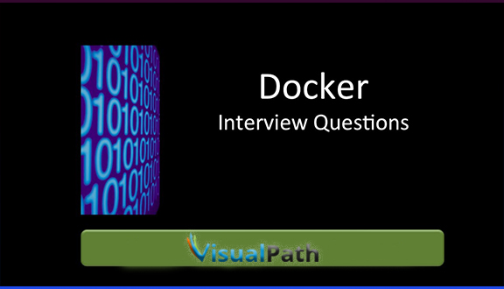

1.Current roles & responsibilities?
2.What is Docker compose?
3.What is Docker server version?
4.What are the advantages of Docker?
5.How do you setup Docker in Jenkins in production environment?
6.How do create Docker image from Docker file?
7.How do you deploy the Docker image generated in the testing environment to
production environment in Jenkins?
8. What is Docker data centre?
9. What is Docker hub & uses?
10. What are the types of Docker networks?
11. How do you define network in the Docker compose file?
12. What are the basic parameters required in the Docker compose file?
13. What is Docker interlock?
14. What is overlay networking?
15. How to communicate between 2 containers present in separate network?
16. How to store the data present in the Docker container in the AWS?
17. If we define the Docker volume in the docker compose file is it possible to share
data with the EFS, NFS?
18. Differnce between image and container
19. How to Run containers
20. Why we need to mention dual ports(8080:8080) in docker run command
21. .Differnce between Copy and Add
22.How to write a docker file to deploy a war file
i. We have private repository and don’t have base images .how can deploy a war file?
ii. Write a simple docker file to deploy a war file by using base images?
23. Difference between docker compose and docker swarm
24. why we need to use docker compose?
25. Tell me about Docker Network.

